Lesson 79, Reading, PI (Crime)
Exercise 1
Look at these pictures. What can you see in each one?
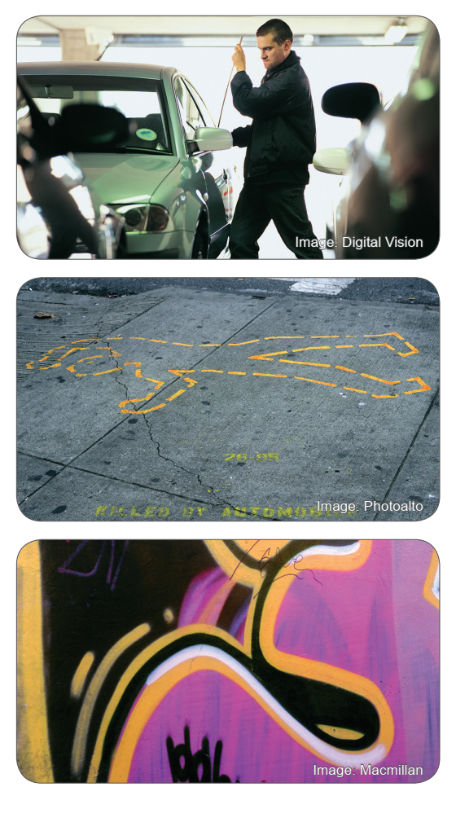

Exercise 2
Complete the headlines with the words in the box.
What do you think happened in each story?
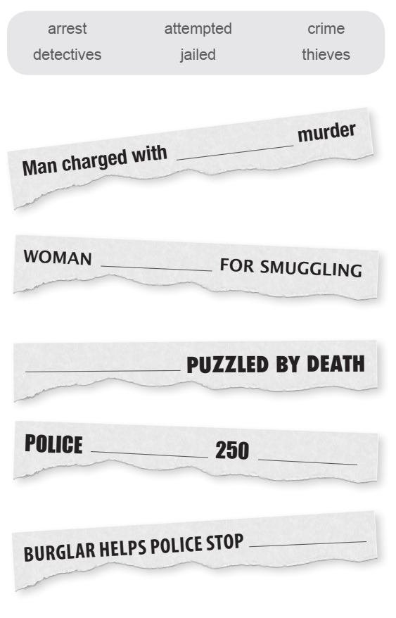

Exercise 3
Read the newspaper stories below and match the headlines from the previous exercise to the correct story.
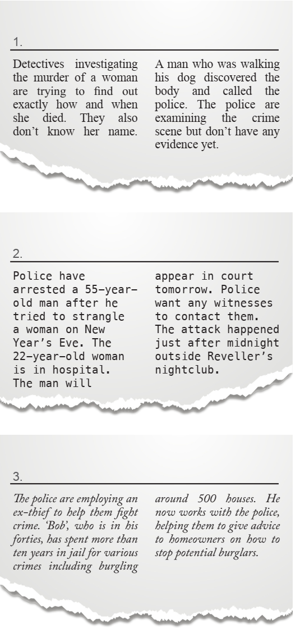

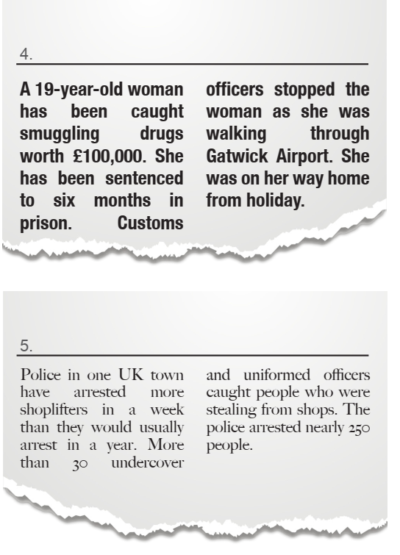

Exercise 4
According to the newspaper stories define whether statements are true or false.
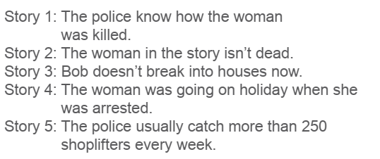
Exercise 5
Find words in the newspaper stories and match them with these definitions.
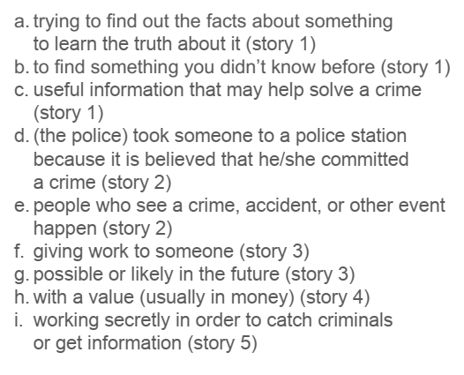
Exercise 6
Put the words in the box in the correct column in the table.
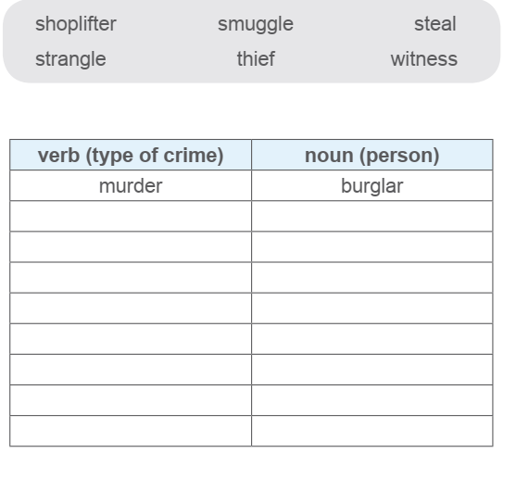

Exercise 7
Answer the following questions.
1. Is crime a serious problem where you live? What kinds of crimes happen often?
2. Do the police do a good job in your country?
3. How do you feel when you see a police officer?
4. How do stores try to stop shoplifting?
5. At what age are we fully responsible for our actions? What is the youngest age that a criminal should be punished as an adult?
6. How do you feel about drunk driving? What is the proper punishment for someone who drinks alcohol and drives?
7. Have you ever seen a crime being committed? What did you see?
8. If a person acts in self-defense and accidentally hurts someone, should they be punished?
9. Is carrying a gun a good way to stay safe? Why or why not?
10. What does ‘crime doesn’t pay‘ mean? Do you agree?

Keys:

Exercise 2:
Man charged with ATTEMPTED murder
Woman JAILED for smuggling
DETECTIVES puzzled by death
Police ARRESTED 250 THIEVES
Burglar helps police stop CRIME

Exercise 3:
1) DETECTIVES puzzled by death
2) Man charged with ATTEMPTED murder
3) Burglar helps police stop CRIME
4) Woman JAILED for smuggling
5) Police ARRESTED 250 THIEVES

Exercise 4:
Story 1- False; Story 2- True; Story 3- True; Story 4- False; Story 5- False

Exercise 5:
a. investigating; b. discovered; c. evidence; d. arrested; e. witnesses; f. employing; g. potential; h. worth; i. undercover
Exercise 6:
