Lesson 80, Speaking, PI (Politics)
Exercise 1
Match the items on the right to the items on the left.
Exercise 2

Fill the gaps with a necessary word.

candidate canvass election floating voters hardliners left-wingers polling station right-winger vote

1) She is supported by in the party.
2) You can cast your vote at the local .
3) In 1918 British women got the right to .
4) However, there was a significant minority of : on average about 20 percent of the electorate.
5) The Prime Minister has been criticized by in his party for giving away too much in the treaty.
6) He stood as a in the local elections.
7) Peter's older brother, Johnny, was also a .
8) The prime minister may decide to call an early .
9) The party needs to the uncommitted voters.

Exercise 3
How can you comment on the following quotes?

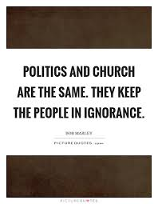
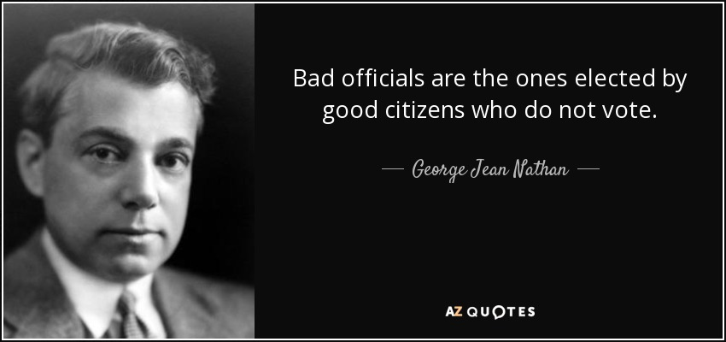
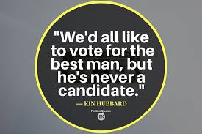

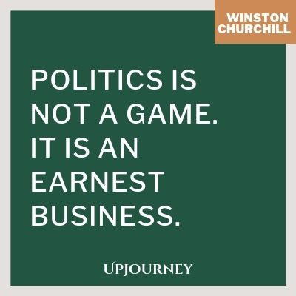

Exercise 4
Answer the following questions.
1. How much are you interested in politics?
2. Can you tell some recent political news?
3. How often do you read articles or watch TV programs on political issues?
4. Do you like talking about politics?
5. What are the main political problems in your country?
6. What do you think about your country’s political system?
7. What do you think about your country’s politicians?
8. What qualities make a good political leader?
9. Did you vote in the last election?
10. How do you decide who or what to vote for?
11. How have your political views changed during your lifetime?
12. How is it possible to get more people to vote?
13. How do you feel about stars who run for a position in politics?
14. Would you like to work in politics?
15. If you were a politician, what problems would you focus on?
16. What are the main political issues in the world?
17. What can cause a war?
18. What would the world be like without politics?

Keys:

Exercise 1:

Exercise 2:

1) She is supported by left-wingers in the party.
2) You can cast your vote at the local polling station.
3) In 1918 British women got the right to vote.
4) However, there was a significant minority of floating voters: on average about 20 percent of the electorate.
5) The Prime Minister has been criticized by hardliners in his party for giving away too much in the treaty.
6) He stood as a candidate in the local elections.
7) Peter's older brother, Johnny, was also a right-winger.
8) The prime minister may decide to call an early election.
9) The party needs to canvass the uncommitted voters.

