Lesson 82, Video, PI (Summer Holidays)
Exercise 1
Match the verbs on the left to the words on the right to make summer phrases.
Exercise 2
Choose the correct word to complete each of the sentences below.
Sun sunbathe sunburn sunny sunshine suntan cream

1.Let’s sit here. There’s more at this table.
2. It is better to in the morning or evening when the sun is weaker.
3. The weather tomorrow is going to be .
4. Remember to put on when you go to the beach.
5. Put on a hat and cream to stop .
6. We are going to stay and watch the go down.

Exercise 3
Match the ways to book a holiday to the statements.
Exercise 4
Cross out the incorrect answers to complete each fact below. Then listen to the audio to check your answers.
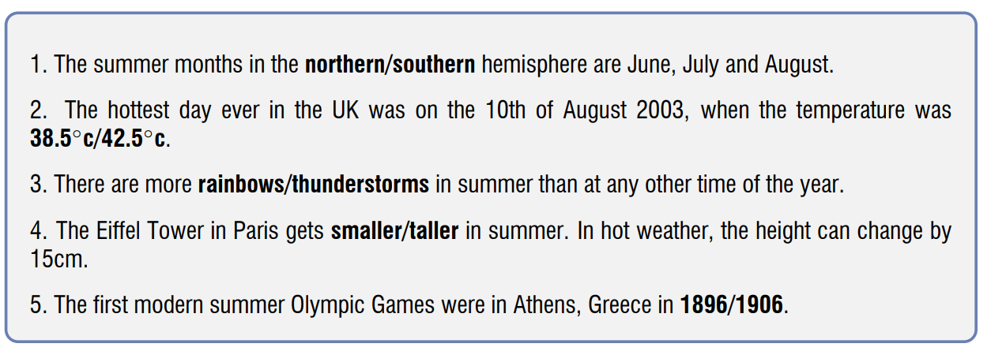
Exercise 5
Watch the video first and then complete the dialogues.
Are going to watch are you going to buy are you going to do are you going to stay ‘m (just) going to meet ‘m going to buy ‘m going to do ‘m going to meet ‘m going to visit ‘re going to enjoy ‘s going to be you are going to meet

Dialogue 1
1. So what in Madrid?
2. I my relatives.
3. And how long there?
4. I imagine all your cousins, aunts and uncles.
5. It great.
Dialogue 2
6. What on Oxford Street?
7. I some shopping.
8. And what ?
9. I some clothes.
10. I some friends. We a film together.
Dialogue 3
11. I a friend for coffee.
12. I the museum.
13. I’m sure you it

Exercise 6
Watch the video about summer holidays in Britain and decide whether statements are true or false.
https://www.youtube.com/watch?v=HfmlzbXLhLs

False True

- June and July are the most popular months for travelling. -
2. The British can choose when to take a two-week break. -
3. British people make almost 30 million holiday trips every year. -
4. Spain is the most visited country. -
5. Weather conditions are the reason why a lot of British people travel abroad. -
6. In Brighton people stay only in hotels. -
7. London isn`t the most popular place for travelling. -

Keys:
Exercise 1:
Exercise 2:
1. sunshine 2. sunbathe 3. sunny 4. suntan cream 5. sunburn 6. sun
Exercise 3:
Exercise 4:
1. December, January and February, 2. 38.5◦ c, 3. thunderstorms, 4. taller 5. 1896
Exercise 5:
1. are you going to do 2. 'm going to visit 3. are you going to stay 4. you are going to meet 5. 's going to be 6. are you going to do 7. 'm going to do 8. are you going to buy 9. 'm going to buy 10. 'm going to meet; are going to watch 11. 'm (just) going to meet 12. 'm going to visit 13. 're going to enjoy
Exercise 6:
- - False
- - True
- - False
- - True
- - True
- - False
- - True

