Exercise 1. Match the holiday words to the pictures.
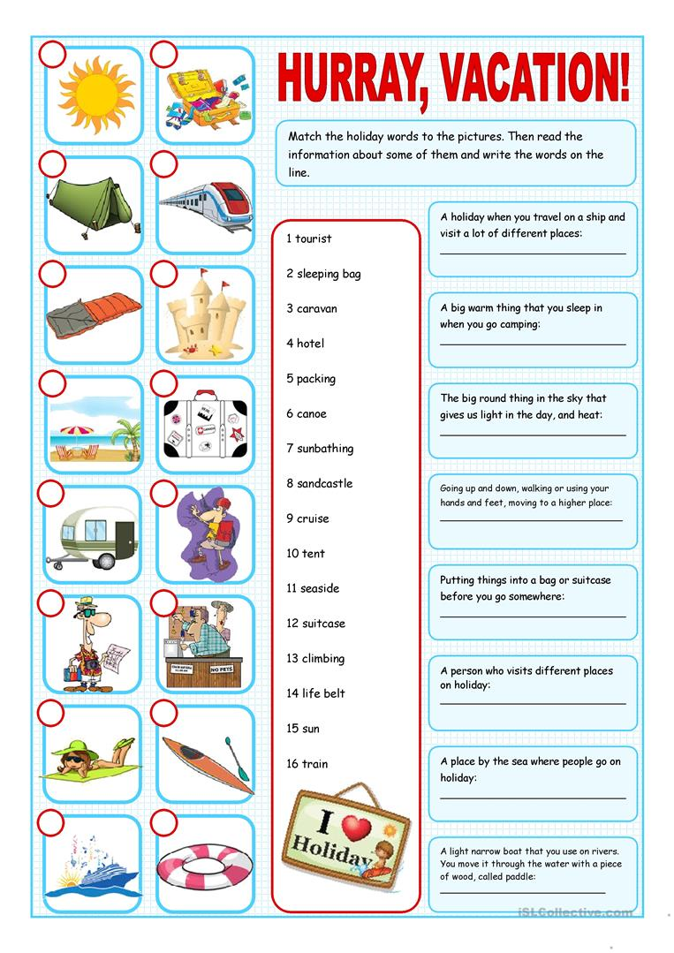

Exercise 2. Match the vocabulary with the correct definition.

Exercise 3. Choose True or False for these sentences.

Exercise 4. Choose the best preposition to complete these sentences.

Exercise 5. Read the texts and answer the questions.
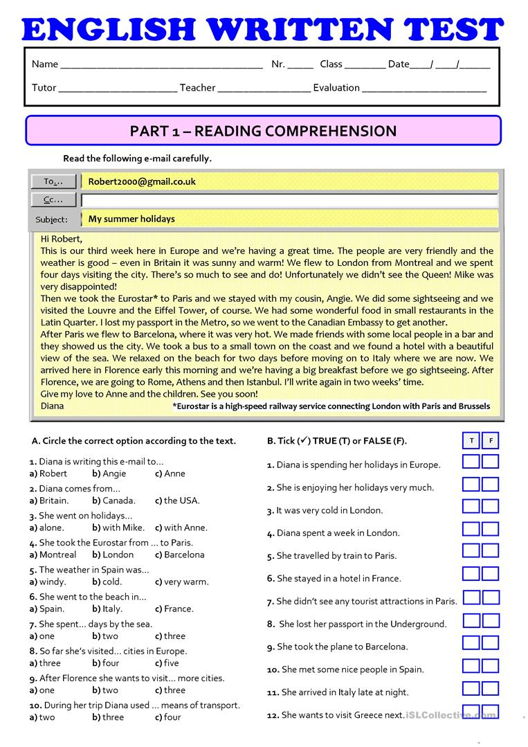

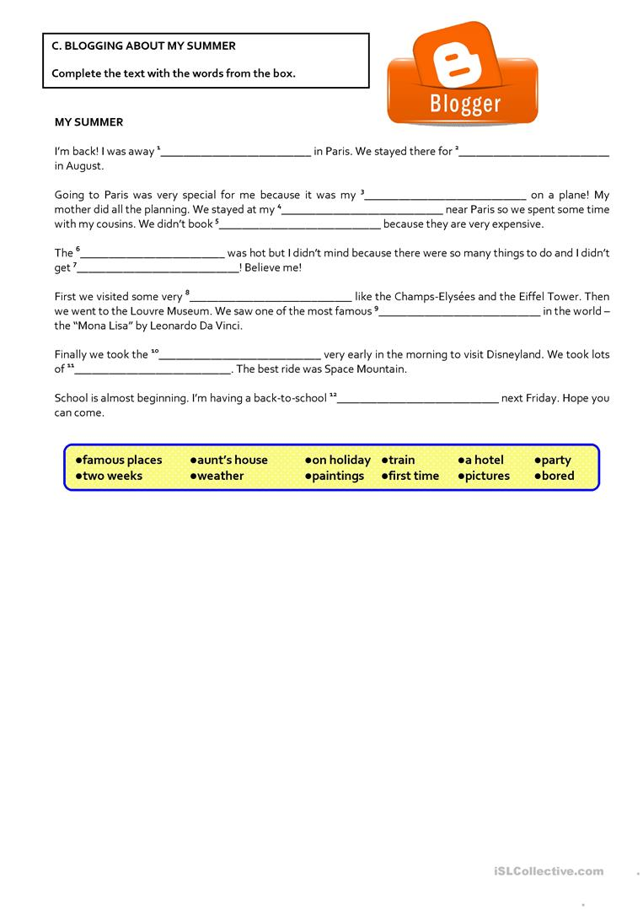

Answers:
Exercise 1. Match the holiday words to the pictures.
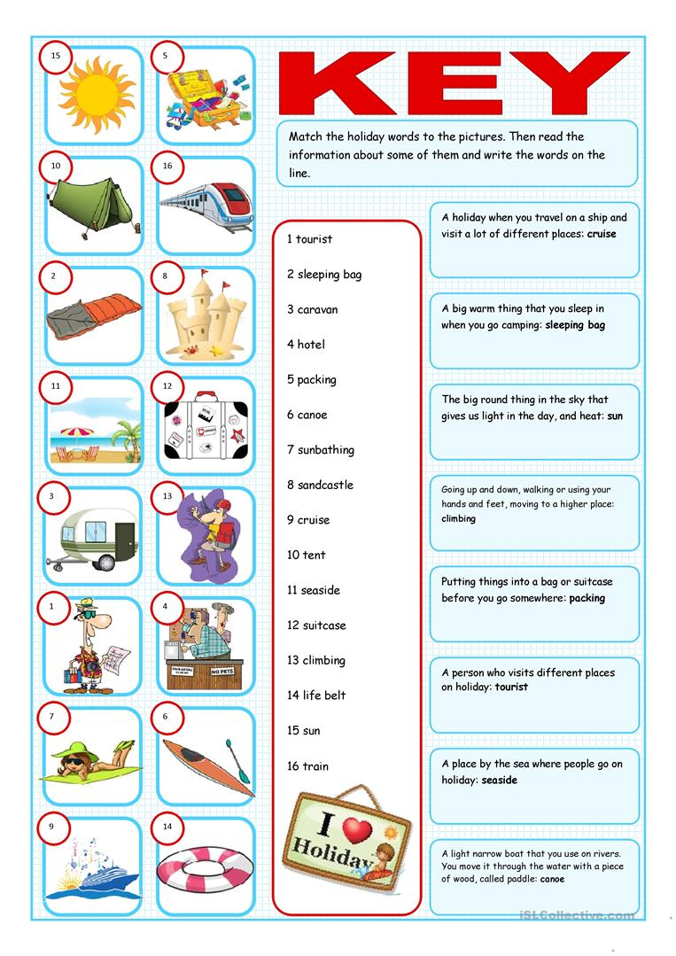
Exercise 5. Read the texts and answer the questions.
