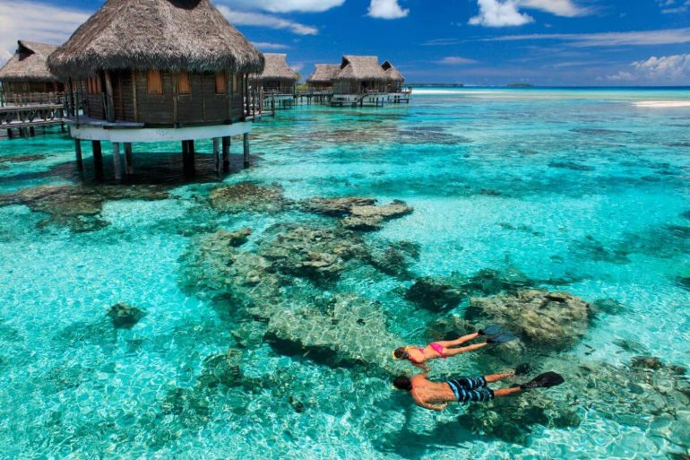
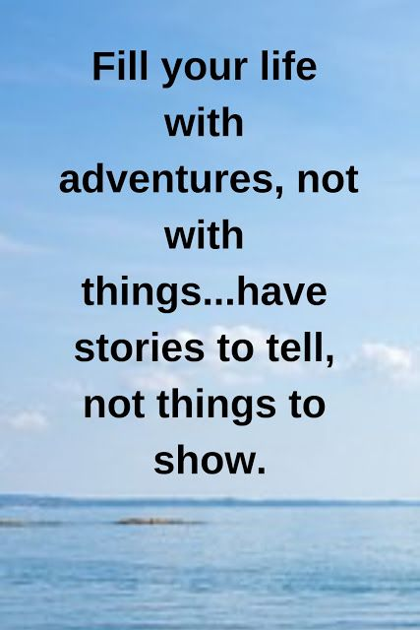

Exercise 1. Describe the pictures and come up with the story of your next summer holidays.
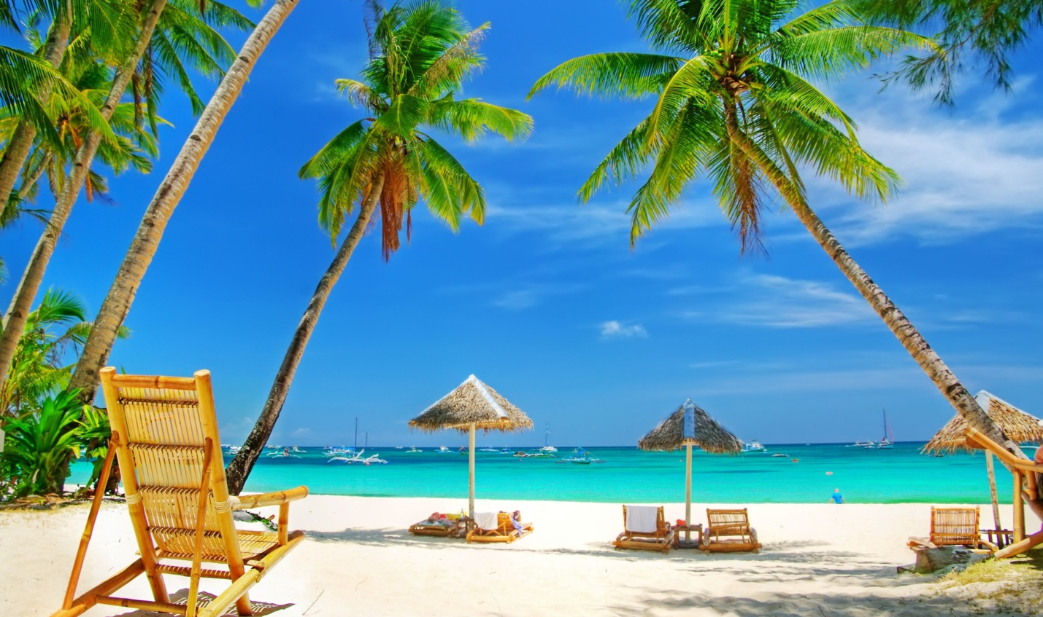
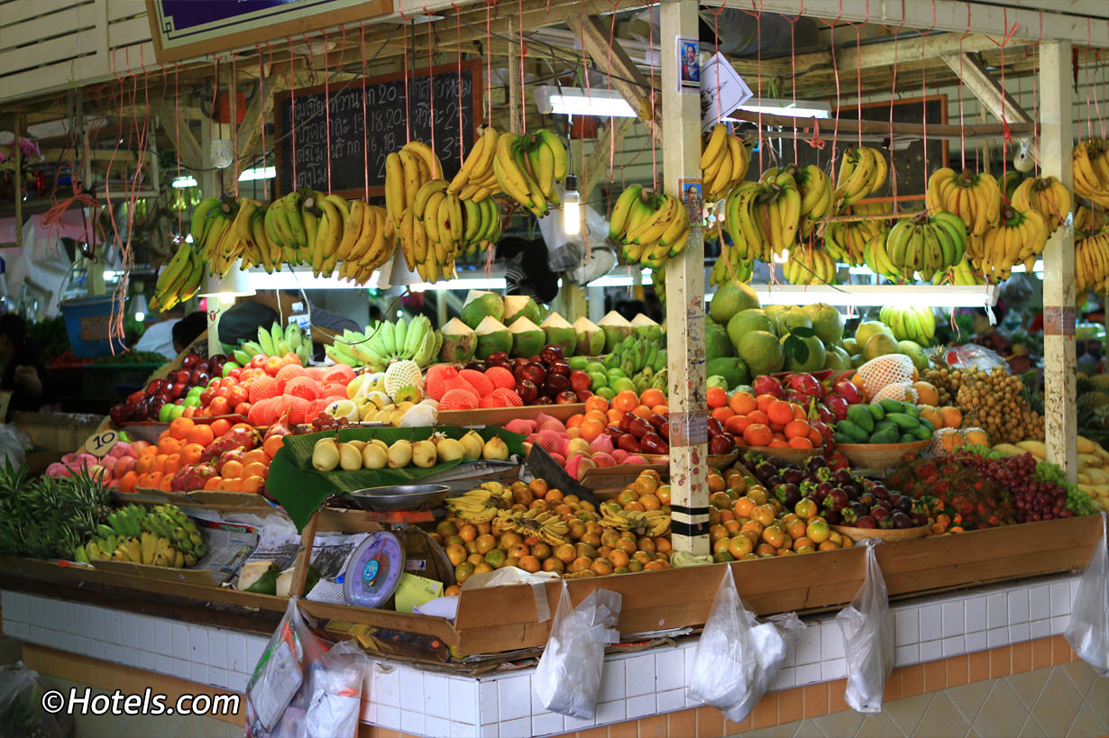
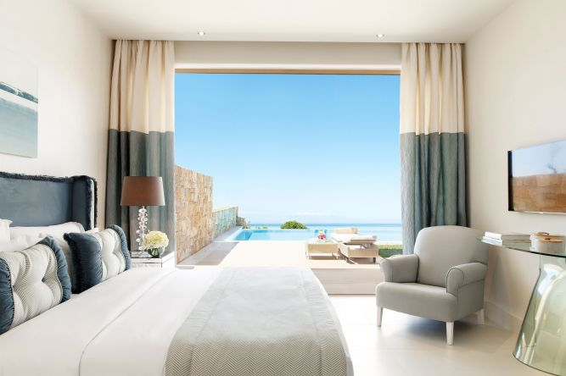
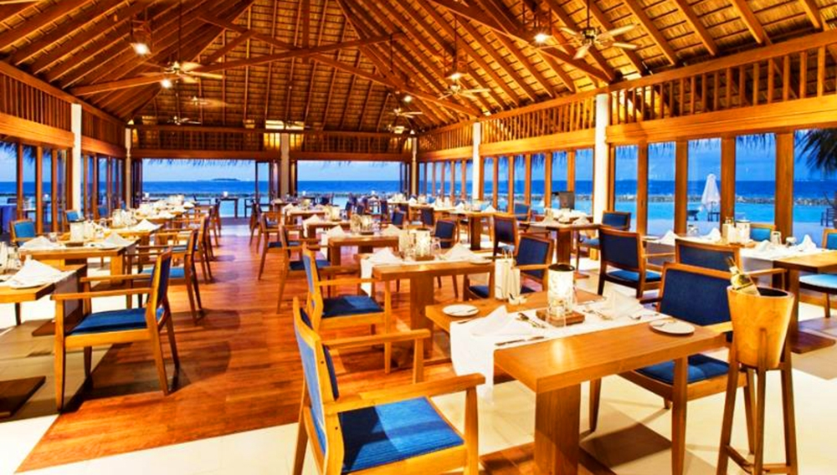
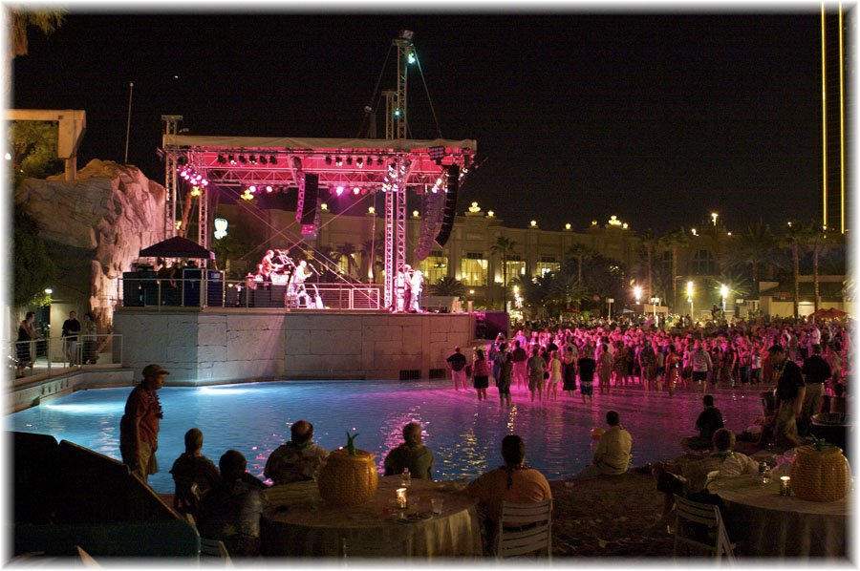

Exercise 2. Answer the questions.
1. Do you prefer beach holidays or sightseeing ones?
2. Do you prefer travelling alone or with somebody?
3. What do you like about travelling?
4. What do you dislike about travelling?
5. How do you like to travel?
6. Do you usually take a lot of luggage or do you travel light?
7. What’s the best hotel you've ever stayed in?
8. What’s the worst hotel you've ever stayed in?
9. What can ruin a holiday?
10. Do you ever get bored when you are on holiday?
11. What do you like doing in a new place?
Exercise 3. What summer holidays nightmares happened to you?
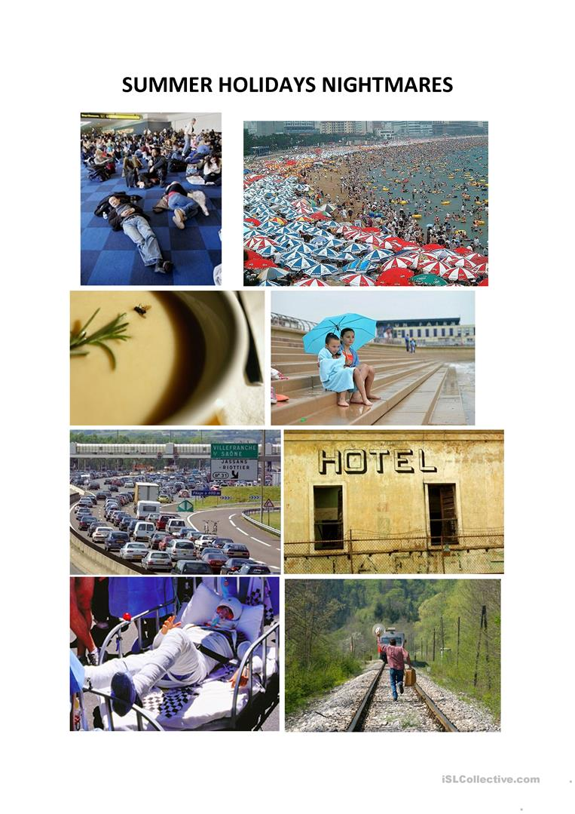

Exercise 4. Watch the video and answer the questions.
<iframe width="560" height="315" src="https://www.youtube.com/embed/w4oTWiZJYHo" frameborder="0" allow="accelerometer; autoplay; encrypted-media; gyroscope; picture-in-picture" allowfullscreen></iframe>

1. Are you good at using maps?
2. Have you ever lost being on holiday?
3. Do you usually take a lot of photos on your holidays?
4. Would you like to live somewhere that you've visited for a holiday?
5. Where was your last holiday?
6. Are you planning your next holiday?
7. If you could go anywhere in the world, where would you go?

